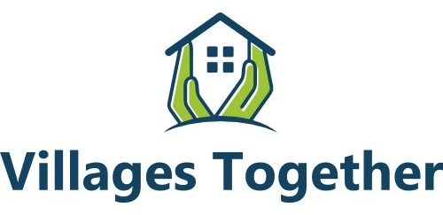
Villages Together Project Evaluation Form
Reminder – Failure to return this form could result in no further grants being awarded to your group/organisation.

Please complete and return this form to villagestogether@gmail.com
Your feedback is important to us, it is used for audit purposes, it enables us to review the grants scheme and the impact of Villages Together funding in the local community.

PLEASE COMPLETE ALL SECTIONS
As a condition of your funding you agreed to provide evidence of how your funding was spent. Please include receipts, photographs, press coverage etc with your application.
PLEASE WRITE CLEARLY
- Name of Organisation and Project

- Did your project take place in Woolavington, Puriton or both villages?

- Project start date Project end date

- How much funding did you receive from Villages Together?

- What was the total cost of your project (including that contributed by Villages Together)?

- What did your project/scheme involve and how was your grant spent? (e.g. erected a youth shelter, enabled start- up of Neighbourhood Watch Scheme, funded summer play scheme)?

- How did/does your project benefit local people and approximately how many?

- How did/does your project benefit your group or organisation and were there any unintended benefits? (for example, allowed you to recruit new members, helped achieve your aims, gave the group more confidence, helped bring the group together, allowed you to buy needed equipment etc).

- What were the key learning points from your project and were there any unintended outcomes?

- Do you consider your project/scheme has proved a success and if so, why?

- Did you obtain any publicity for this project or scheme and was the contribution from Villages Together acknowledged in any publications e.g. press articles or newsletters? (please tick) Yes/ No

- Please enclose examples of all publicity acknowledging Villages Together contribution to your project.

Name
Address
Tel No/Email: Date:
Thank you for taking time to complete this evaluation form. Please return the completed evaluation form to: villagestogether@gmail.com

